

MULTIMEDIA UNIVERSITY OF KENYA

FACULTY OF COMPUTING AND INFORMATION TECHNOLOGY

PROJECT DOCUMENTATION
E-VOTING SYSTEM
BY
REBECCA NJOKI
CIT-227-058/2019

SUPERVISOR: KELVIN KARIS
APRIL, 2024

Submitted in partial fulfillment of the requirements of Bachelor of Science in Software Engineering

DECLARATION

I hereby declare that this project is my own work and has, to the best of my knowledge, not been submitted to any other institution of higher learning.
Student : Rebecca Njoki Registration Number: CIT-227-058/2019

Signature: ............................................... Date: 25th April 2024
This project has been submitted as a partial fulfillment of requirements for the Bachelor of Science in Software Engineering of Multimedia University of Kenya with my approval as the University supervisor.
Supervisor: Kelvin Karis
Signature: ..................................................... Date: ..................................................

ACKNOWLEDGMENT

I would like to express my sincere gratitude to my family, friends, supervisor and classmates who have played pivotal roles in the successful completion of this project.
Your contributions have been instrumental in the success of this project. Thank you for your dedication, expertise, and support.

ABSTRACT

This project aims to develop a secure, accessible, and user-friendly e-voting system that enhances the voting experience while ensuring the integrity and transparency of the electoral process. The methodology involves a thorough analysis of existing e-voting systems, identification of security vulnerabilities, and the design and development of a customized solution that addresses these issues.
The system employs advanced encryption techniques, multi-factor authentication, and a robust access control mechanism to ensure the security and privacy of voter data. User experience is enhanced through an intuitive interface, support for multiple languages, and accessibility features for voters with disabilities.
The results of the project include a fully functional e-voting system that has been tested and validated through user acceptance testing and security assessments. The system has demonstrated a significant improvement in voting efficiency and accuracy, with a reduction in the time required to complete the voting process and a decrease in the likelihood of human errors.
The conclusion of the project is that the developed e-voting system is a viable and secure alternative to traditional paper-based voting systems. The system's features and functionalities have been well-received by users, and it has the potential to transform the electoral process by increasing voter participation and confidence in the system.
Recommendations for future work include continuous monitoring and evaluation of the system's performance, regular security assessments, and the development of additional features such as voter education modules and real-time election results reporting.

Table of Contents
DECLARATION 2
ACKNOWLEDGMENT 3
ABSTRACT 4
List of Abbreviations 6
List of Figures 7
1. CHAPTER ONE 8
1.0 INTRODUCTION 8
1.1 Background of Study 8
1.2 Problem Statement 8
1.4 Significance of the Study 10
1.7 Limitations 11
2. CHAPTER TWO 12
2.0 LITERATURE REVIEW 12
2.1 Introduction 12
2.2 Related Systems 12
2.3 Weaknesses of these systems 12
2.4 How the Proposed Solution will handle these weaknesses 13
3. CHAPTER THREE 16
3.0 METHODOLOGY 13
4. CHAPTER FOUR 17
4.0 SYSTEM ANALYSIS 17
4.1 Detailed analysis of current system 17
4.2 System Requirements 18
5. CHAPTER FIVE 22
5.0 SYSTEM DESIGN 20
6. CHAPTER SIX 26
6.0 IMPLEMENTATION AND TESTING 26
7. CHAPTER SEVEN 27
7.0 CONCLUSION 27
References 28
Appendix 28

List of Abbreviations

IEBC- Independent Electoral and Boundaries Commission
PKI- Public Key Infrastructure
E-voting- Electronic Voting

List of Figures

Figure 1 15
Figure 2 17
Figure 3 18
Figure 4 20
Figure 5 20
Figure 6 21
Figure 7 21
Figure 8 22
Figure 9 22
Figure 10 23
Figure 11 23
Figure 12 24
Figure 13 24
Figure 14 26
Figure 15 26

1. CHAPTER ONE

1.0 INTRODUCTION

1.1 Background of Study
The Independent Electoral and Boundaries Commission (IEBC) of Kenya
The IEBC is a relatively young organization, established in 2010 following the promulgation of the new Kenyan Constitution. This marked a significant reform effort after a history of electoral violence in the country. The aim was to create an independent body, free from government or political party influence, to oversee and ensure free and fair elections.
The IEBC is tasked with a critical role in Kenyan democracy: managing all aspects of the electoral process. Here's a breakdown of its key functions:
1. Conducting and supervising elections: This includes national presidential elections, parliamentary elections, and local government elections.
2. Maintaining the national voter register: The IEBC ensures accurate and up-to-date voter registration data through registration drives and data management.
3. Setting boundaries for constituencies and wards: This involves dividing the country into electoral units for fair representation.
4. Educating the public on the electoral process: The IEBC plays a crucial role in informing voters about their rights, responsibilities, and how to participate in elections.
The IEBC's core aims and objectives revolve around achieving the following:
1. Free and Fair Elections: Ensuring every vote is counted accurately and reflects the will of the people.
2. Transparency and Credibility: Maintaining transparency in all electoral processes to build public trust.
3. Inclusivity and Participation: Encouraging and facilitating participation of all eligible voters in the electoral process.
4. Peaceful Elections: Promoting peaceful conduct of elections and mitigating the risk of violence.

1.2 Problem Statement
The problem statement revolves around the need for a secure, efficient, and transparent voting process that addresses the limitations and vulnerabilities of traditional paper-based and electronic voting systems. The proposed e-voting system aims to provide a set of protocols that ensure the integrity, confidentiality, and accuracy of the voting process while enabling voters to cast their ballots remotely and conveniently.
The existing electronic voting systems suffer from security vulnerabilities, such as the risk of tampering, unauthorized access, and privacy breaches, which can undermine the credibility and trustworthiness of the electoral process. Additionally, these systems often lack transparency, making it difficult for voters and election officials to verify the accuracy and fairness of the results.

To address these challenges, the proposed e-voting system employs advanced cryptographic techniques, such as end-to-end encryption, blind signatures, and homomorphic encryption, to ensure the confidentiality and integrity of the voting process. The system also implements a robust access control mechanism, multi-factor authentication, and a secure voter identification system to prevent unauthorized access and tampering. Furthermore, the system provides a user-friendly interface, support for multiple languages, and accessibility features for voters with disabilities, enhancing the voting experience and increasing voter participation.
The e-voting system project aims to develop a secure, efficient, and transparent electronic voting system that addresses the limitations and vulnerabilities of traditional paper-based and electronic voting systems. The proposed system employs advanced cryptographic techniques, robust access control mechanisms, and a user-friendly interface to ensure the integrity, confidentiality, and accuracy of the voting process while enabling voters to cast their ballots remotely and conveniently.

1.3 Aim of study
The aim of the e-voting system project is to design and implement a secure and trustable online-based voting system based on Public Key Infrastructure (PKI). The project focuses on conducting field studies to investigate the use and effects of online voting, contributing to technological development and increasing users' trust in information society technology tools for services like voting.
The objective is to create a system that allows users to express their opinions securely through electronic voting, integrated with existing PKIs, and to demonstrate the advantages and possibilities of secure electronic voting. The project aims to explore the acceptance, usability, and implications of the system on voter trust and turnout, ultimately enhancing the voting experience and increasing confidence in the electoral process.

1.3.1 Research Objectives
1. Develop a secure and trustable online voting system based on Public Key Infrastructure (PKI) that addresses the limitations and vulnerabilities of traditional paper-based and electronic voting systems.
2. Employ advanced cryptographic techniques, such as end-to-end encryption, blind signatures, and homomorphic encryption, to ensure the confidentiality and integrity of the voting process.
3. Implement a robust access control mechanism, multi-factor authentication, and a secure voter identification system to prevent unauthorized access and tampering.
4. Provide a user-friendly interface, support for multiple languages, and accessibility features for voters with disabilities, enhancing the voting experience and increasing voter participation.
5. Conduct field studies to investigate the use and effects of online voting, contributing to technological development and increasing users' trust in information society technology tools for services like voting.
6. Evaluate the system's performance, security, and usability, and compare its merits with existing online voting schemes to reduce discovery redundancy and streamline the effort towards a secure and trusted online voting system.
7. Ensure the system supports a multi-user environment, is fully automated, and provides concrete security features like creating users and assigning privileges to users of the system.
8. Keep track of all the detailed descriptions of the client and the whole details of services offered by the client organization, and make various outputs (reports) available online any time.
9. Handle extremely large volumes of data (i.e. large database support) and ensure the system is capable of keeping track of all the detailed descriptions of the client and the whole details of services offered by the client organization.
10. Investigate the use and effects of online voting, contributing to technological development and increasing users' trust in information society technology tools for services like voting.

1.4 Significance of the Study
The significance of the study of e-voting systems lies in its potential to enhance the democratic process by increasing voter participation, improving efficiency, and ensuring the integrity of elections. This study focus on addressing security concerns, enhancing user trust, and exploring the impact of electronic voting on voter behavior and perceptions.
By investigating factors like privacy, usability, learning effects, and organizational aspects, these research endeavors aim to contribute valuable insights that can shape the development and implementation of secure and reliable e-voting systems. Ultimately, the significance of this study lies in their ability to advance electoral technology, strengthen democratic practices, and foster public confidence in the electoral process.

1.5 Scope
The scope of the e-voting system project is to develop a secure and user-friendly electronic voting system that allows voters to cast their ballots remotely and conveniently.
The goal is to ensure that voters can express their opinions securely and confidently, thereby improving the overall quality of the electoral process. The scope of the study is limited to the development of a rental management system for real estate companies.

1.6 Assumptions
1. Security and Reliability: The e-voting system should be secure and reliable, with the security and reliability of the system not relying on the secrecy of the network or any other physical assumptions.
2. Transparency: The whole voting process must be transparent, with bulletin boards used to publicize the election process.
3. Mobility: An e-voting system is mobile if there is no restriction on the location from which a voter can cast a vote.
4. Efficiency: The processes involved in the e-voting system should be done efficiently, with the complexity of the counting process being O(n).
5. Convenience: The e-voting system should allow voters to cast their votes quickly, in one session, without any extra equipment or special skills.
6. Privacy: The e-voting system should ensure the privacy of the voter, with the identification being much more sensitive than in traditional voting media.
7. Usability: The e-voting system should be user-friendly, with a clear and easy-to-use graphical user interface.
8. Accessibility: The e-voting system should be accessible to all voters, including those with disabilities.
9. Learning Effects: The outcomes of the tests may be influenced by all kinds of contingent problems that accompany the tests, and the system should be designed to handle these issues.
10. Organizational Aspects: The implementation of the system and the organization of the ballot in the various test sites should be studied to understand the social, organizational, political, legal problems that occur and why.

1.7 Limitations
1. Costs and Maintenance: Opponents of e-voting argue that the acquisition and maintenance costs of e-voting systems are higher than traditional voting systems, especially if e-voting is not offered as the unique voting channel but only as an alternative.
2. Security and Privacy: E-voting systems are susceptible to security threats, such as hacking, tampering, and unauthorized access, which can compromise the confidentiality and integrity of the voting process.
3. Accessibility: While e-voting systems aim to increase accessibility, they may still exclude certain groups, such as those without access to technology or those with disabilities, from participating in the voting process.
4. Technical Complexity: E-voting systems can be technically complex, requiring specialized knowledge and expertise to design, implement, and maintain, which can limit their adoption and use.
5. Lack of Public Trust: E-voting systems may not be trusted by the public, who may be skeptical of the security and reliability of electronic systems, which can affect their willingness to participate in the voting process.
6. Legal and Regulatory Challenges: E-voting systems may face legal and regulatory challenges, such as compliance with election laws and regulations, which can limit their adoption and use.
7. Dependence on Technology: E-voting systems are dependent on technology, which can be prone to failure, such as power outages, network disruptions, or system crashes, which can affect the voting process.
8. Lack of Transparency: E-voting systems may lack transparency, making it difficult for voters and election officials to verify the accuracy and fairness of the results, which can undermine public trust in the electoral process.
9. User Experience: E-voting systems may not provide a user-friendly experience, which can affect the usability and accessibility of the system, and limit the participation of certain groups, such as older adults or those with limited technology literacy.
10. Lack of Standardization: E-voting systems may lack standardization, which can limit their interoperability and compatibility, and affect their adoption and use.

2. CHAPTER TWO

2.0 LITERATURE REVIEW

2.1 Introduction
The e-voting system provides an advanced method of conducting voting as compared to the current existing paper voting system.

2.2 Related Systems
Paper-based voting systems involve a rigorous process where eligible voters are identified, enumerated, and issued voter IDs. On the day of polling, voters have to go to the polling stations and cast their votes manually. The counting of votes is also done manually, which can be tedious, error-prone, and costly.
Lever voting machines are mechanical devices that allow voters to cast their votes by pulling a lever next to their preferred candidate's name.

2.3 Weaknesses of these systems
Paper-Based Voting Systems:
1. Reliability Concerns: Paper-based voting systems, especially those without a paper trail, lack the reliability and accuracy of modern electronic systems. The manual counting process can be error-prone, time-consuming, and subject to human biases, potentially leading to inaccuracies in the vote count.
2. Vulnerability to Manipulation: Paper-based systems are vulnerable to manipulation, especially when vote counting rules allow for selective exclusion of votes based on technicalities. This selective counting can be exploited by controlling the vote counting teams to exclude votes for the opposition, undermining the fairness of the election process.
3. Complexity in General Elections: Paper-based systems face challenges in handling complex general elections with multiple candidates and offices on the ballot. The complexity of counting votes accurately in such elections can be difficult and time-consuming, potentially leading to delays and inaccuracies in the results
Lever Voting Machines:
1. Security Vulnerabilities: Lever voting machines are prone to security vulnerabilities, as they are not secure against vote fraud and tampering. Technicians can easily manipulate the machines to limit the number of votes registered for a particular candidate without detection, undermining the integrity of
2. Lack of Audit Trail: Lever voting the voting process. machines do not maintain an audit trail, making it impossible to recount votes in case of allegations of fraud. This lack of transparency and accountability raises concerns about the accuracy and fairness of the election results.
3. Complexity and Maintenance: Lever voting machines are complex, expensive to move and store, difficult to test, and require specialized maintenance. Their size and maintenance challenges make them less practical and secure compared to modern electronic voting systems.

2.4 How the Proposed Solution will handle these weaknesses
1. Use of Encryption: E-voting systems can use encryption to secure the communication channel between the voter and the voting system, ensuring that the vote is not intercepted or tampered with during transmission.
2. Digital Signatures: Digital signatures can be used to authenticate the voter's identity, ensuring that only eligible voters can cast their votes.
3. Audit Trails: E-voting systems can maintain an audit trail of all votes cast, allowing for post-election audits to ensure the accuracy and integrity of the results.
4. Paper Records: E-voting systems can provide a paper record of each vote cast, allowing for manual recounts and verification of the results.
5. Secure Software: The e-voting system software should be designed with security in mind, ensuring that it is free from vulnerabilities that could be exploited by attackers.
6. Regular Updates: The e-voting system software should be regularly updated to address any newly discovered vulnerabilities.
7. Physical Security: E-voting systems should be physically secured to prevent tampering or unauthorized access.
8. Testing and Certification: E-voting systems should be thoroughly tested and certified to ensure that they meet security standards.
9. User Training: Voters should be trained on how to use the e-voting system to ensure that they can cast their votes securely and accurately.
10. Transparency: The e-voting system should be transparent, allowing for public scrutiny and verification of the results.

3. CHAPTER THREE

3.0 METHODOLOGY

3.1 Introduction
The methodology used in this project is the Agile methodology. Agile methodology is a flexible and iterative approach to software development that focuses on delivering working software at regular intervals.

3.2 Methodology
The methodology involves the use of sprints, daily stand-up meetings, and continuous integration. The project resources include software developers, designers, and project managers. Agile development methodology is a technique that is used to show how the proposed system will be developed. In this case, the methodology used will be a waterfall model.
Waterfall Model
It is consists of the stages that the developer will use when developing the system. It is a sequential model hence, the name waterfall. The developer has to finish with one stage before going to the next one. It comprises of the feasibility study, analysis phase, design phase, coding phase, testing phase, implementation phase and finally the maintenance phase. It is a simple model and easy to use and understand.
The analysts and users proceed sequentially from one phase to the next. The deliverables from each phase are voluminous and are presented to the project sponsor for approval as the project moves from phase to phase. Once the phase is approved by the sponsor it ends and the next phase begins.

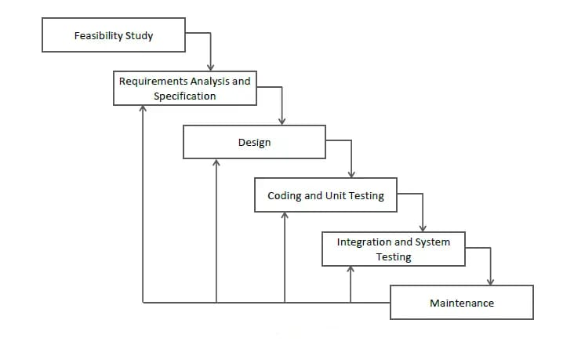
Figure 1

Agile methodology is well-suited for the e-voting system project as it offers flexibility, iterative development, enhanced collaboration, risk mitigation, and a customer-centric approach, all of which are essential for the successful development of a secure, efficient, and user-friendly e-voting system.

3.3 Data collection methods and tools
User Stories: User stories are a way to capture the requirements and needs of the users in the Agile methodology. They are short, simple descriptions of the features and functionalities that the users want in the e-voting system. User stories can be collected through interviews, surveys, or focus groups with the stakeholders, including voters, election officials, and political parties.
Use Cases: Use cases are scenarios that describe how the users will interact with the e-voting system. They can be used to identify the user requirements, system constraints, and system functionalities. Use cases can be collected through user interviews, observations, or usability testing.
Iterative Development: The Agile methodology involves iterative development, where the system is developed in small increments, and feedback is collected after each iteration. The data collection tools for iterative development include user feedback, usability testing, and system performance metrics.
Continuous Integration: Continuous integration is a practice in Agile methodology where the code is integrated and tested frequently. The data collection tools for continuous integration include automated testing, code review, and bug tracking.
Retrospective: A retrospective is a meeting held at the end of each iteration to reflect on the development process and identify areas for improvement. The data collection tools for retrospective include feedback forms, surveys, and interviews with the development team and stakeholders specifications. The output of this step is one or more product components built according to a predefined coding standard and debugged, tested and integrated to satisfy the system architecture requirement.

4. CHAPTER FOUR

4.0 SYSTEM ANALYSIS

4.1 Detailed analysis of current system
Sequence diagram of IEBC registration process

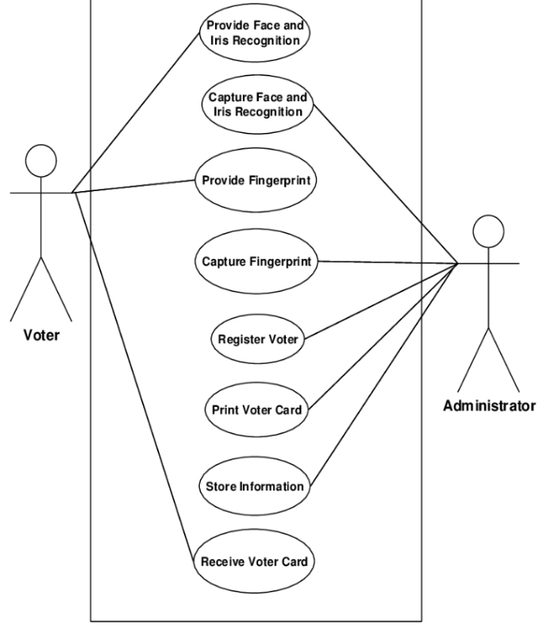
Figure 2

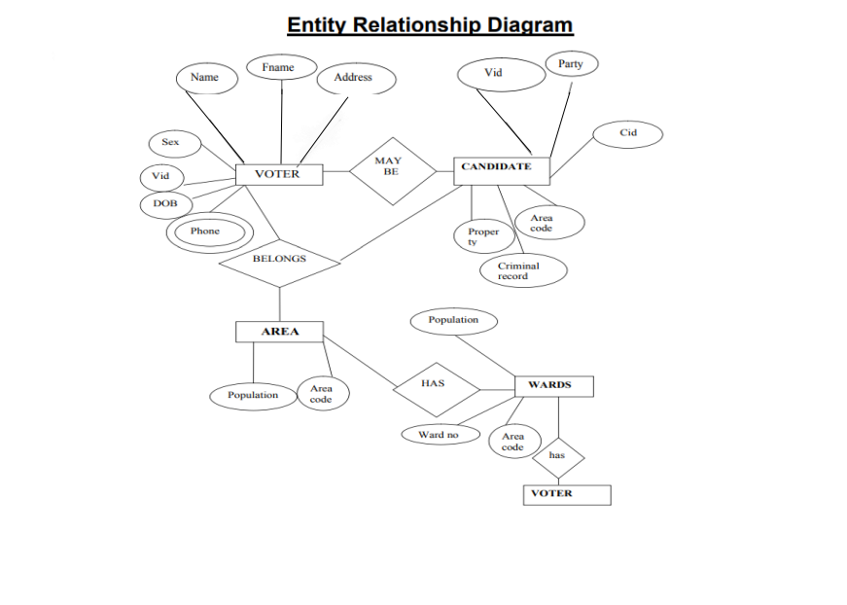
Figure 3

4.2 System Requirements
System requirements are a set of specifications that define what the system should do. The system requirements can include features such as: Platform--------------------Linux
Back end--------------------PhP
Database-----------------MySQL
Technologies used-------JSP, JDBC
Designer tool--------------HTML, CSS, Bootstrap
Server-----------------------Apache tomcat 5.5.9

4.2.1 Functional Requirements
Are a set of specifications that define the functions that the system should perform. The functional requirements can include features such as voter registration, candidate registration, online voting, tallying, results report.

4.2.2 Non-Functional Requirements
Are a set of specifications that define the performance, security, and usability of the system. The non-functional requirements can include features such as system scalability, data security, and user interface design.

5. CHAPTER FIVE

5.0 SYSTEM DESIGN

5.1 Architectural design

Flow of data and personnel involved diagram 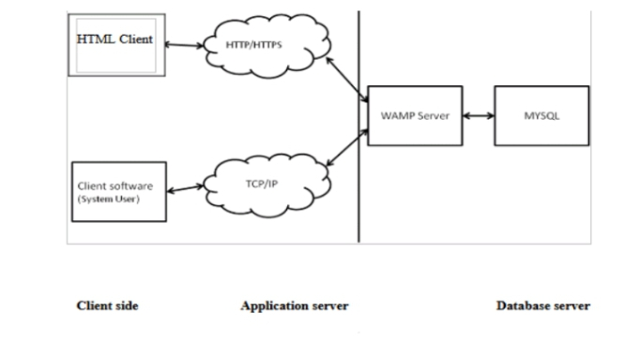
Figure 4
Context diagram

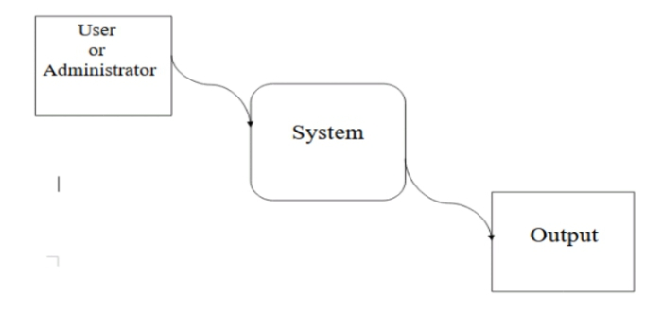
Figure 5

Activity diagram for voter's registration process

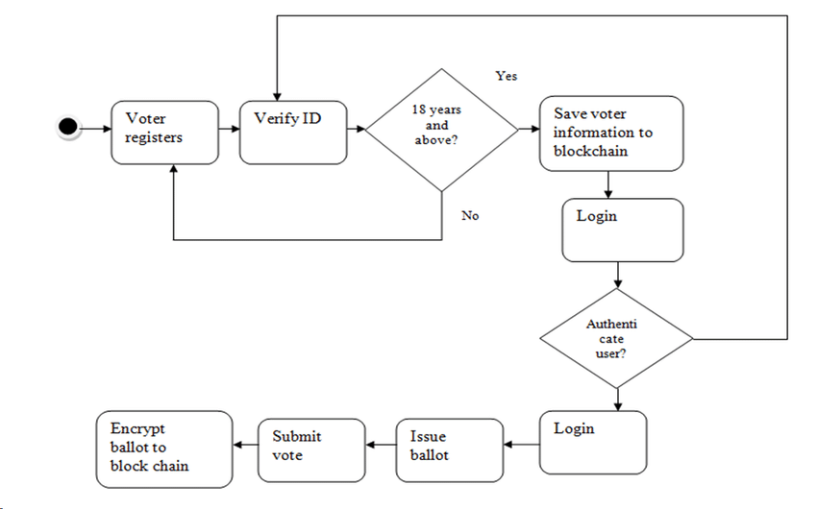
Figure 6

Authentication process of Sequence diagram

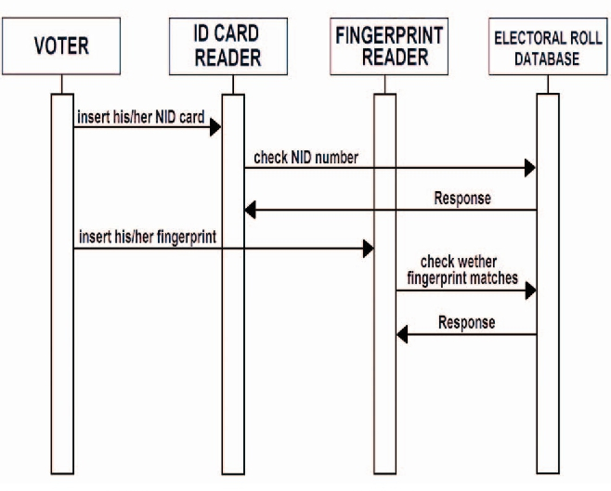
Figure 7

Collaboration diagram

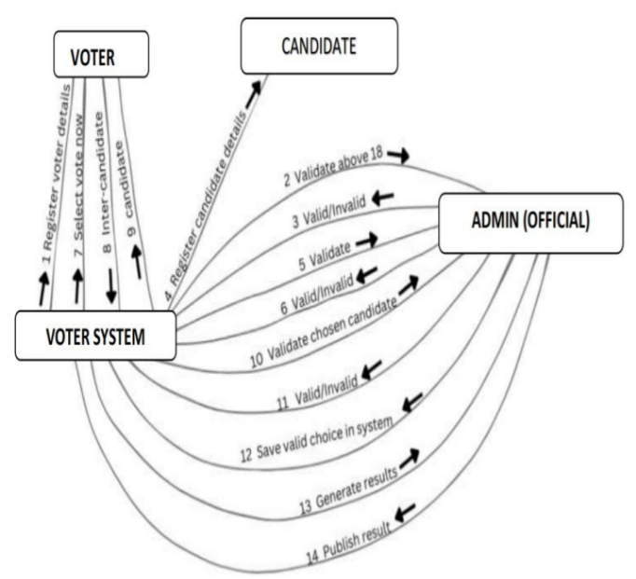
Figure 8

5.2 Database design

Admin's view
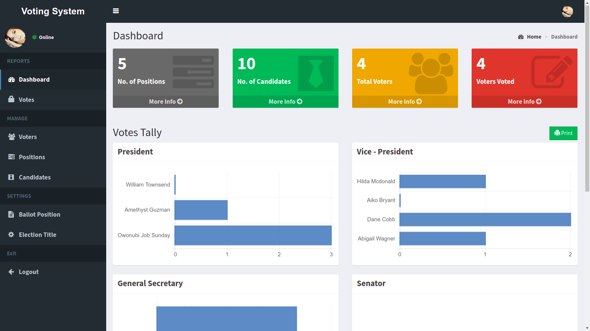
Figure 9

Results form


Figure 10

Voters data

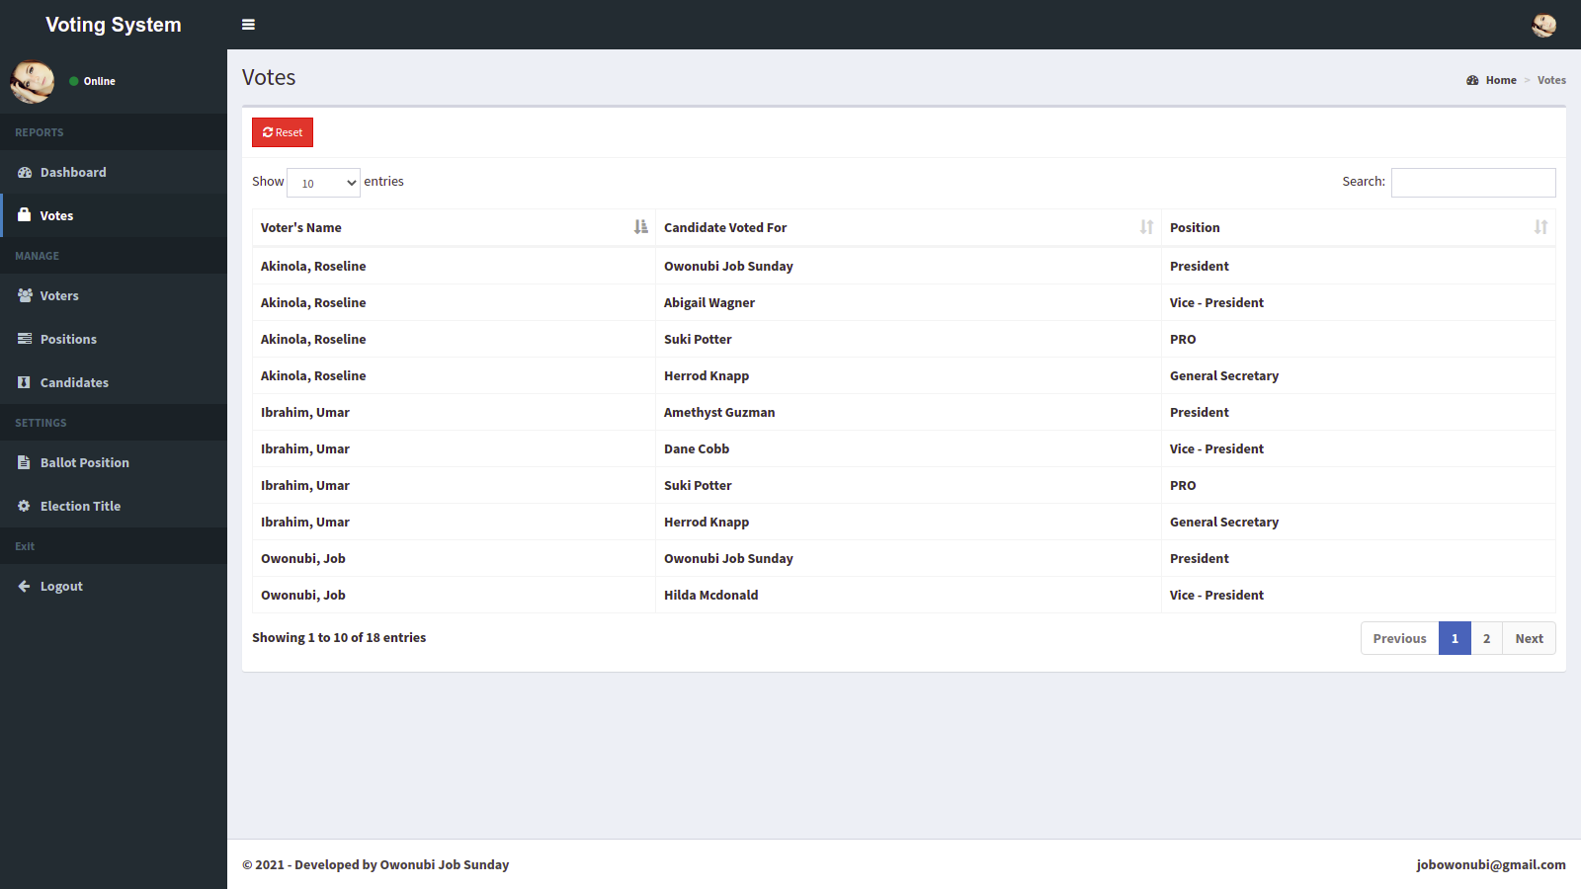
Figure 11

Entity Relationship diagram 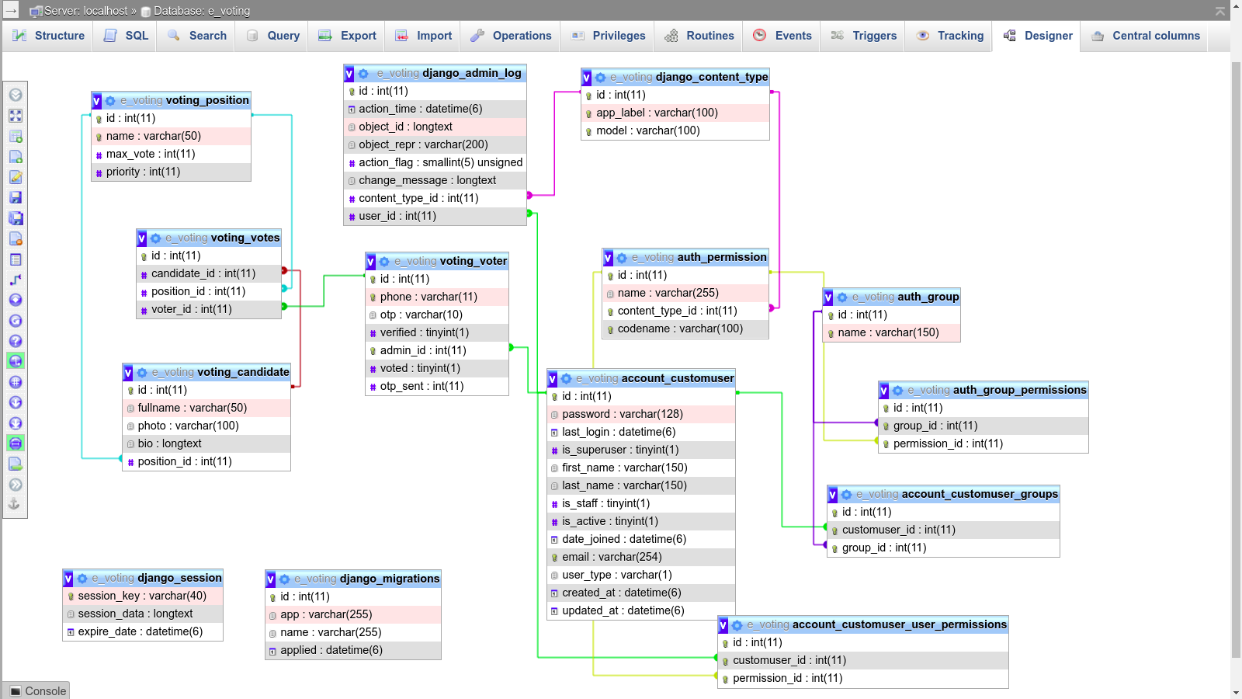
Figure 12

5.3 User interface design
User log in interface


Figure 13

6. CHAPTER SIX

6.0 IMPLEMENTATION AND TESTING

6.1 Development Environment
The development environment for the e-voting system project running on a XAMPP server with MySQL database and PHP back-end should include the following components:
XAMPP Server: The XAMPP server is a free and open-source software package that includes Apache, MySQL, PHP, and other components to create a local web development environment. The XAMPP server should be installed on a secure and reliable computer or server.
MySQL Database: The MySQL database is a popular open-source relational database management system that is used to store and manage the e-voting system's data. The MySQL database should be configured to ensure data integrity, confidentiality, and availability.
PHP Back-End: The PHP back-end is a server-side scripting language that is used to manage the e-voting system's business logic and data processing. The PHP back-end is developed using a robust framework to ensure scalability and maintainability.

6.2 System Components
Front-End: The front-end of the e-voting system includes a user-friendly interface for voters to cast their votes, view election results, and access election information. The front-end is developed using modern web technologies, such as HTML, CSS, and Bootstrap.
Back-End: The back-end of the e-voting system includes a secure and scalable server-side application to manage the voting process, including voter authentication, vote casting, and vote counting. The back-end is developed using PHP and a framework.
Database: The e-voting system includes a secure and scalable MySQL database to store voter information, election results, and other relevant data. The database is designed to ensure data integrity, confidentiality, and availability.
Security: The e-voting system includes robust security measures, such as encryption, authentication, and access control, to ensure the confidentiality, integrity, and availability of the system.

6.3 Test Plan
Test Data: It includes a representative sample of voter information, election results, and other relevant data. The test data should be designed to test the system's functionality, performance, and security.
Test Cases: Includes a set of scenarios to test the system's functionality, performance, and security. The test cases cover all the system components, including the front-end, back-end, database, and security measures.
Test Results: Include a detailed report of the test cases, including the test data, test environment, test results, and any issues or bugs identified. The test results should be used to improve the system's functionality, performance, and security.

Correct data


Figure 14
Incorrect data


Figure 15

7. CHAPTER SEVEN

7.0 CONCLUSION

7.1 Achievements
1. Planned approach towards working: - The working in the organization will be well planned and organized. The data will be stored properly in data stores, which will help in retrieval of information as well as its storage.
2. Accuracy: - The level of accuracy in the proposed system will be higher. All operation would be done correctly and it ensures that whatever information is coming from the center is accurate.
3. Reliability: - The reliability of the proposed system will be high due to the above stated reasons. The reason for the increased reliability of the system is that now there would be proper storage of information.
4. No Redundancy: - In the proposed system utmost care would be that no information is repeated anywhere, in storage or otherwise. This would assure economic use of storage space and consistency in the data stored.
5. Immediate retrieval of information: - The main objective of proposed system is to provide for a quick and efficient retrieval of information.
6. Immediate storage of information: - In manual system there are many problems to store the largest amount of information.
7. Easy to Operate: - The system should be easy to operate and should be such that it can be developed within a short period of time and fit in the limited budget of the user.

7.2 Conclusions
The e-voting system project has the potential to improve the voting process by increasing accessibility, accuracy, and efficiency. However, the successful implementation of e-voting systems requires a commitment to addressing security and usability issues, ongoing research and development efforts, and education for election officials, poll workers, voters, and the general public.
The flexibility of e-voting systems allows for a wide range of performance and functionality, but technical realities such as the potential for small software changes to result in substantial changes to the system's behavior and the limitations of testing alone in proving the absence of problems must be taken into account.
Trusted election processes should be regarded as the gold standard of election administration, and e-voting systems should be designed and implemented with this goal in mind. The e-voting system project should prioritize security, accessibility, and the specific requirements of the organization's voting event, providing a convenient and efficient alternative to traditional voting methods. Overall, the e-voting system project has the potential to modernize the voting process and promote civil rights, but careful consideration and planning are necessary to ensure its success.

7.3 Recommendations
It is essential to establish a robust project management framework that includes clear goals, timelines, budgets, and milestones.
A risk management plan should be established to identify and mitigate potential risks and issues.
Regular evaluations and assessments of the system should be conducted to ensure it meets the needs of the organization and its stakeholders.
By following these recommendations, the e-voting system project can help ensure the success of the implementation and promote civil rights, convenience, accuracy, and cost savings while maintaining security, accessibility, and the specific requirements of the organization's voting event.

References
1. Chisnell, Dana E., and Susan C. Becker. "Style Guide for Voting System Documentation." USENIX. Available at: [PDF] Style Guide for Voting System Documentation - USENIX
2. Chisnell, Dana E., Susan C. Becker, Sharon J. Laskowski, and Svetlana Z. Lowry. "Style Guide for Voting System Documentation." GovInfo. Available at: [PDF] Style guide for voting system documentation - GovInfo
3. Council of Europe. "A practical guide to introducing e-voting." Available at: [DOC] A practical guide to introducing e-voting - The Council of Europe
4. Federal Voting Assistance Program (FVAP). "Electronic Voting Demo Project." Available at: Electronic Voting Demo Project - FVAP.gov
5. International Institute for Democracy and Electoral Assistance (International IDEA). "Introducing Electronic Voting: Essential Considerations." Available at: [PDF] Introducing Electronic Voting: Essential Considerations - EODS

Appendix
Data collection tools: questionnaires
Project schedule: 6 months

